LABORATORIYA MASHG’ULOTI

|  |  |  |
| --- | --- | --- |
| FAN NOMI |  | Algoritmlarni loyihalash |
| HAFTA |  | 2 |
| MAVZU: |  | Matrisalarni ko’paytirish dasturi. Amallar tartibini baholash. |
| ISHDAN MAQSAD: |  | Algoritmlar tahlili va murakkabligi:  1. Matritsalarni ko’paytirish algoritmi 2. O(n) - murakkablik; 3. O(n3) - murakkablik; |

**Matritsani ko'paytirish**

**Matritsalarni ko’paytirish formulasi**

https://i1.wp.com/konspekta.net/megaobuchalkaru/imgbaza/baza12/331669162627.files/image081.gif.

**1-masala.**

Ikkita matritsa berilgan. Ularning ko’paytmasini toppish algoritmi va dasturini tuzing.

$$\left(\begin{aligned}1 1 1 \\ 1 2 2 \\ 1 2 3\end{aligned}\right)\left(\begin{aligned}1 1 1 \\ 1 2 2 \\ 1 2 3\end{aligned}\right)=\left(\begin{aligned}1+1+1 1+2+2 1+2+3 \\ 1+2+2 1+4+4 1+4+6 \\ 1+2+3 1+4+6 1+4+9\end{aligned}\right)=\left(\begin{aligned}3 5 6 \\ 5 9 11 \\ 6 11 14\end{aligned}\right)$$

**Dastur kodi.**  
#include <iostream>

using namespace std;//ulchamlari bir xil bulgan matritsalar uchun

int main()

{

int a[10][10],b[10][10],c[10][10],r,d,i,j,k;

cout<<"satrlar soni=";

cin>>r;

cout<<"ustunlar soni=";

cin>>d;

cout<<"matritsa elementlarini kiriting=\n";

for(i=1;i<=r;i++)

{

for(j=1;j<=d;j++)

{

cin>>a[i][j];

}

}

cout<<"ikkinchi matritsa elementlarini kiriting=\n";

for(i=1;i<=r;i++)

{

for(j=1;j<=d;j++)

cin>>b[i][j];}

for(i=1;i<=r;i++)

{

for(j=1;j<=d;j++)

{

c[i][j]=0;

for(k=1;k<=d;k++)

{

c[i][j]+=a[i][k]*b[k][j];

}

}

}

//natijani chop qilish

for(i=1;i<=r;i++)

{

for(j=1;j<=d;j++)

{

cout<<c[i][j]<<" ";

}

cout<<"\n";

}

return 0;

}

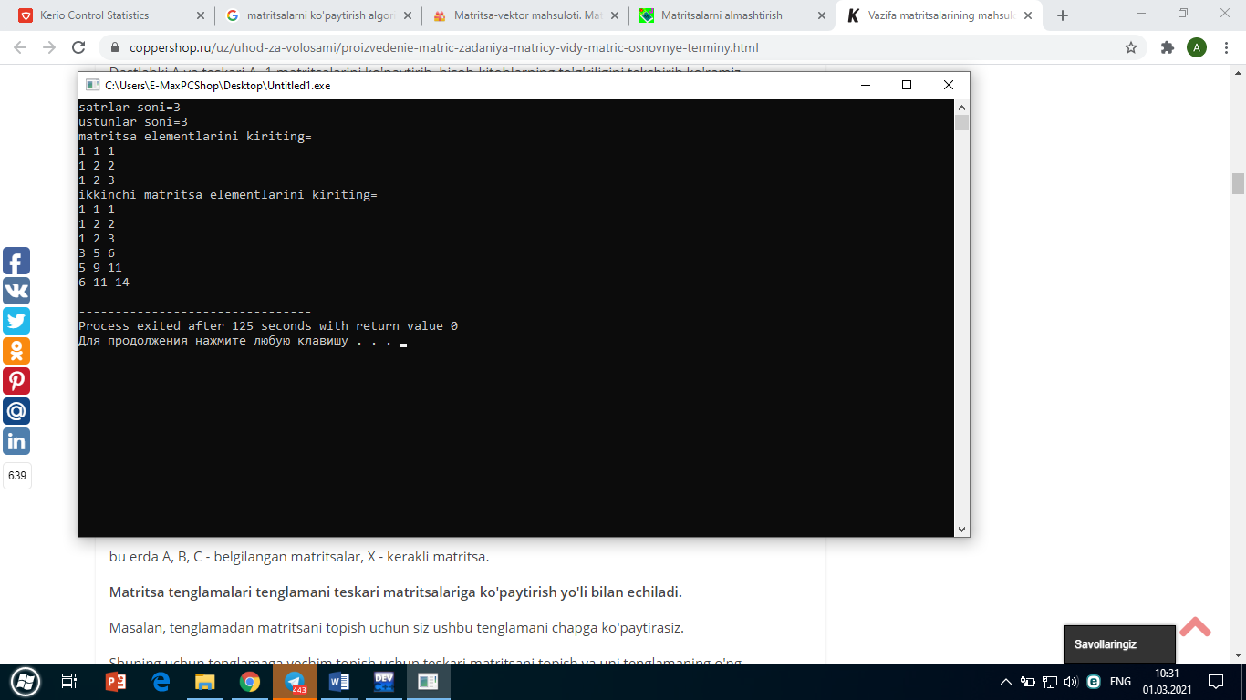

Bu algoritm O(n3) murakkablik bilan baholanadi. Chunki, algoritmda 3 ta ichma-ich sikl operatoridan foydalanilgan.

**for(i=1;i<=r;i++)**

**{**

**for(j=1;j<=d;j++)**

**{**

**c[i][j]=0;**

**for(k=1;k<=d;k++)**

**{**

**c[i][j]+=a[i][k]*b[k][j];**

**}**

**}**

**}**

**Laboratoriya ishi uchun topshiriqlar**

1. Ketma-ketlikning yig’indisini toping $S=\sum_{i=1}^{∞}{\frac{1}{i}}=1+\frac{1}{2}+\frac{1}{3}+…$; Sikl takrorlanishi $\frac{1}{n+1}-\frac{1}{n}<0.0001$. Algoritm samaradorligini baholang.
2. 2 ta kvadrat matritsa berilgan. Ularning yig’indisini toppish algoritmini toping va uni samaradorligini baholang.

3. n o’lchamli kvadrat matritsa berilgan. Uning teskari matritsasini toppish algoritmini toping va uni samaradorligini baholang.